

**One Housing Group**

**SSIS Project Documentation**

**Document Distribution List**

|  |  |
| --- | --- |
| Name | Company |
| Warren Wills-Bray |  |
| Mohammad Khan |  |
|  |  |

**Document Information**

|  |  |
| --- | --- |
| **Details** | |
| Document Name | SSIS Project Documentation |
| Responsibility of | Mohammad Khan |

**Document Control**

|  |  |  |  |  |
| --- | --- | --- | --- | --- |
| **Status** | **Version** | **Date Amended** | **Reason** | **Amended by** |
| Issued | 1.0 | 14/12/2016 | Documentation for the SSIS packages | Mohammad Khan |

**Table of Contents**

1 Introduction 3

2 Progress Summery 3

3 Technical Details 4

3.1 Source Control 4

3.2 VM Servers 4

3.3 Database Servers 4

3.4 Databases 5

3.5 SSIS Packages 5-32

# Introduction

SSIS Project involves investigation of SSIS packages scattered on different SQL servers, Establishing their ownership, functions and connections and then consolidation of all SSIS packages at one place storing them on TFS (Source Control) so they can be easily tracked and accessed. Creating SQL Server database environments for DEV and UAT same as current live environments. Upgrade of old SSIS packages to latest version of Visual Studio and deployment of Upgraded and tested packages to Production Server.

# Progress Summery

1. Initial investigation was done. List of all packages was created with their locations; connections etc. in the following excel spreadsheet.

[SSIS\SSIS Pakages List.xlsx](SSIS/SSIS%20Pakages%20List.xlsx)

1. DEV “OHG2K8SQLDEV01” VM server was setup by infrastructure Team to install the SQL Servers.
2. Instances of SQL Server 2008 “OHG2K8SQLDEV01” and 2005 “OHG2K5SQLDEV01\OHG2K5SQLDEV01” were installed on the DEV server to match the current live database environments.
3. Backups of required databases for SSIS packages were restored on to servers.
4. Git Repository was setup to store the SSIS packages on TFS server at the following location.

<http://ohgdevtfs01:8080/tfs/defaultcollection/OHG/OHG%20Team/_git/IntegrationServices>

1. SSIS packages were upgraded to Visual Studio 2015 for SQL Server 2014.
2. Error Handling and logging was implemented for each package.
3. Packages were deployed to the Test server SQL Server 2014 “OHGINTDAT01” into Integration Services Catalogs.
4. SQL Server Agent jobs were setup to schedule and Run the SSIS Packages.
5. SQL Server notifications were setup to notify the Dev team in case of package run failure.
6. Environment and environment variable were created for Package parameters.
7. Packages were tested and issues were fixed.
8. SSIS Packages were deployed on to Staging Server following the same steps as Dev Server.

# Technical Details

## Source Control

Following Folder structure was set on TFS source control to store the SSIS project files.

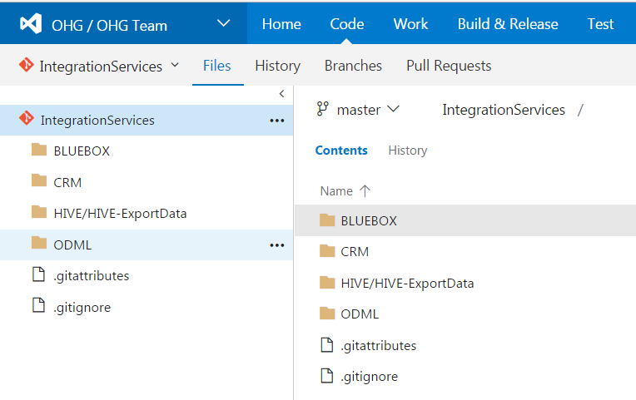

## VM Servers

Following VM servers were setup for SQL servers.



## Database Servers

Following SQL Servers were setup for DEV and UAT database.



## Databases

Following databases were restored from the backups of live database.



## SSIS Packages

### Location

SSIS Packages are source controlled and stored on TFS Server in “Integration Services” Git repository.

<http://ohgdevtfs01:8080/tfs/defaultcollection/OHG/OHG%20Team/_git/IntegrationServices>

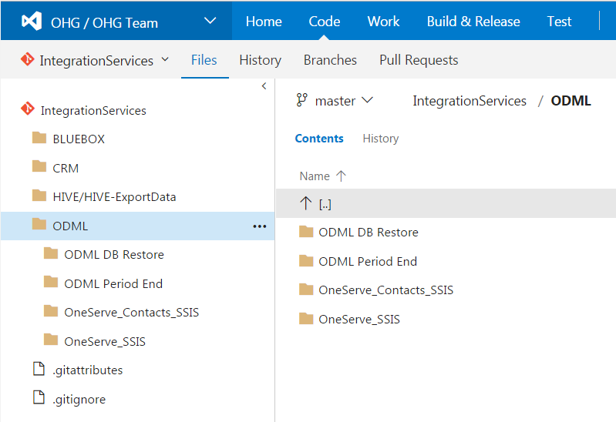

### Packages

**ODML**

1. ODML.dtsx
2. ODML_Contact.dtsx
3. ODML DB Restore.dtsx
4. ODML_Period_End.dtsx

**CRM**

1. crm_repairs.dtsx
2. crm_repairs_overnight.dtsx
3. crm_contacts.dtsx

**BLUEBOX**

1. BlueBox.dtsx
2. BlueBox One.dtsx
3. BlueBox Two.dtsx
4. BlueBox Three.dtsx

**HIVE**

1. Hive Estate Inspections.dtsx
2. **ODML.dtsx**

### Solution and Project:

### 

### Connections:



### Parameters:

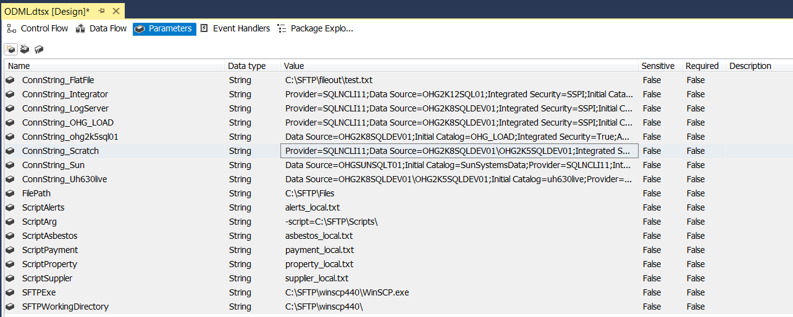

**Control Flow:**

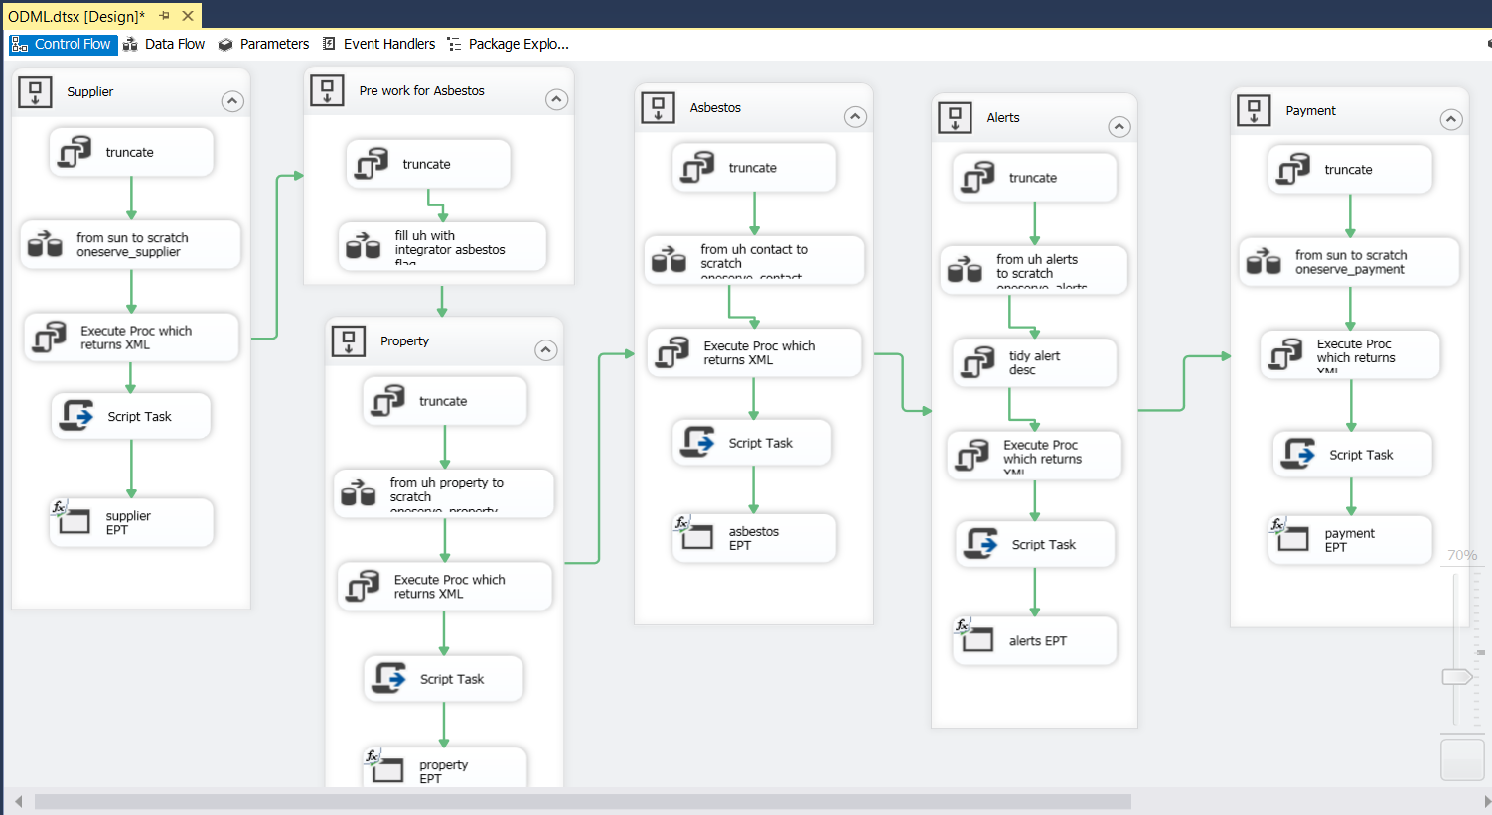

**Deployment:**

Project has been deployed to OHDINTDAT01 (DEV Server) and OHGSTADAT01 (Staging Server)

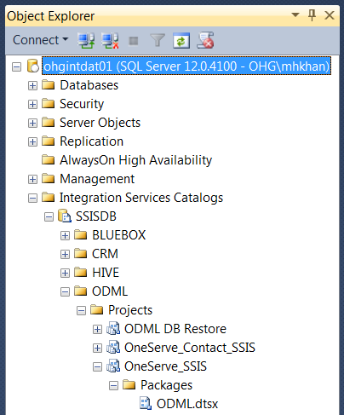

**SQL Server Agent Job:**

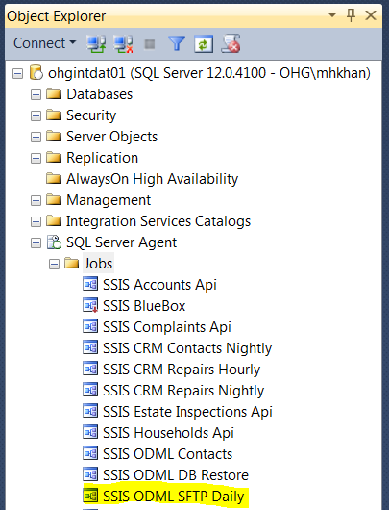

1. **ODML_Contact.dtsx**

### Solution and Project:

### 

### Connections:



### Parameters:

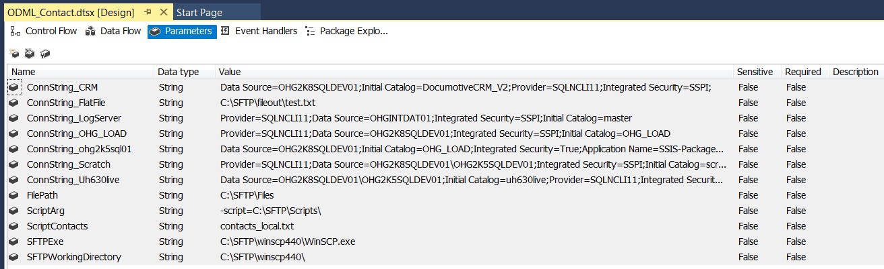

**Control Flow:**

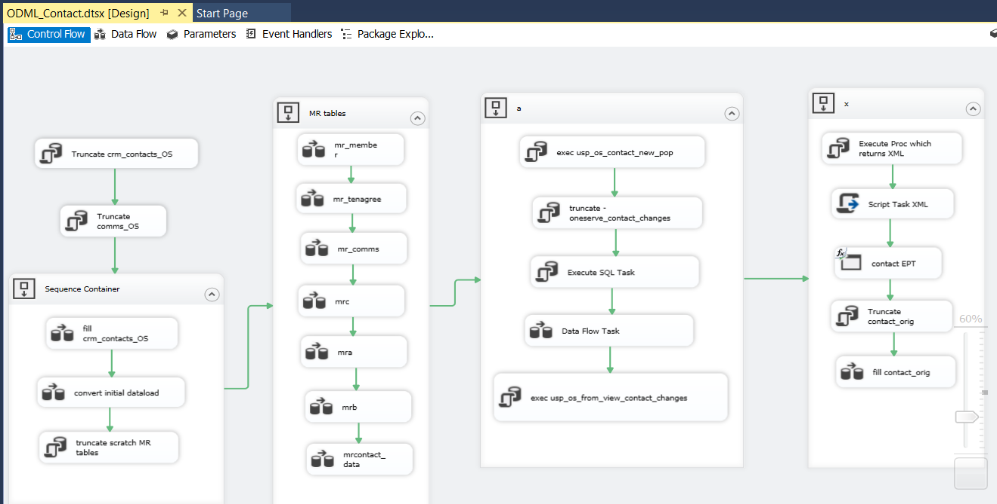

**Deployment:**

Project has been deployed to OHDINTDAT01 (DEV Server) and OHGSTADAT01 (Staging Server)

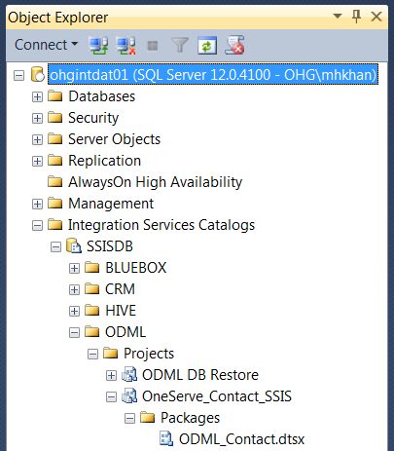

**SQL Server Agent Job:**

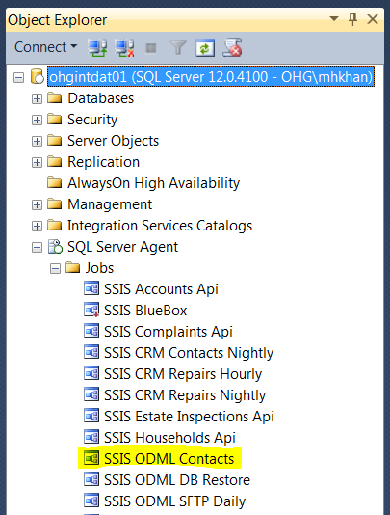

1. **ODML DB Restore.dtsx**

### Solution and Project:

### 

### Connections:



### Parameters:

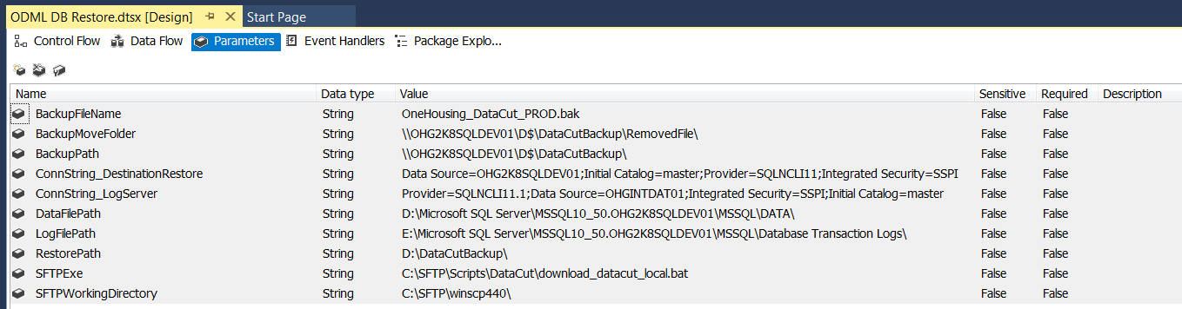

**Control Flow:**

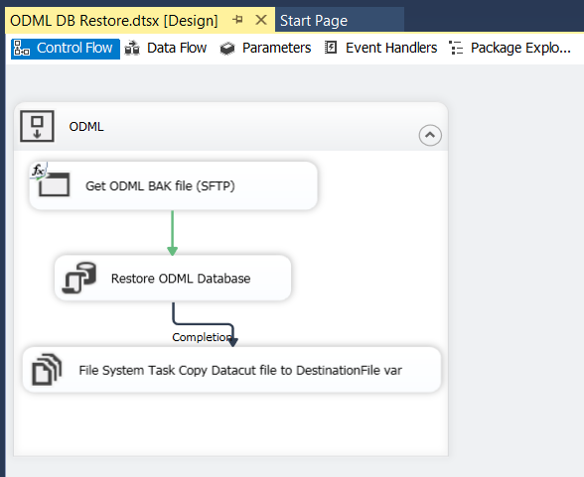

**Deployment:**

Project has been deployed to OHDINTDAT01 (DEV Server) and OHGSTADAT01 (Staging Server)

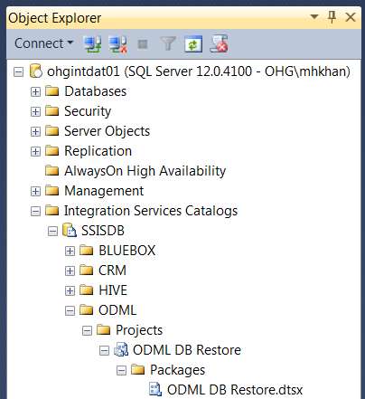

**SQL Server Agent Job:**

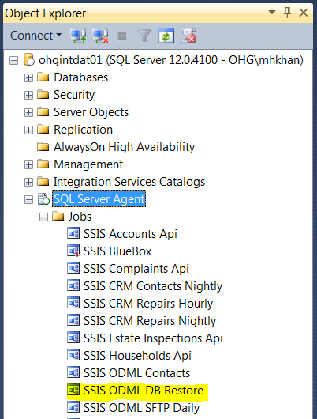

1. **ODML_Period_End.dtsx**

### Solution and Project:

### 

### Connections:



### Parameters:

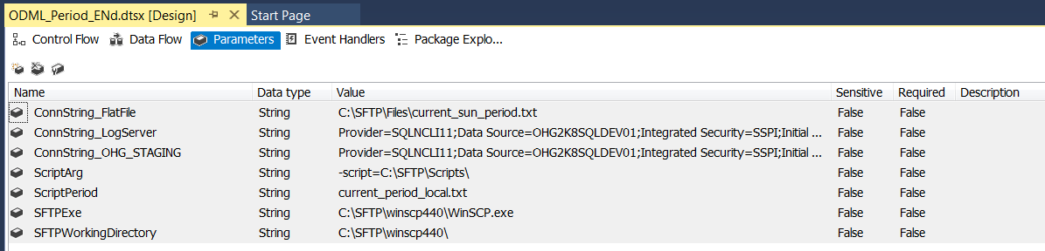

**Control Flow:**

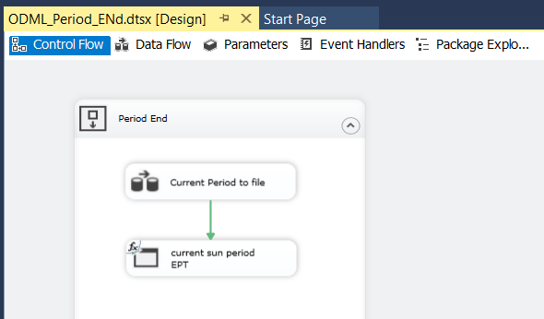

**Deployment:**

Project has been deployed to OHDINTDAT01 (DEV Server) and OHGSTADAT01 (Staging Server)

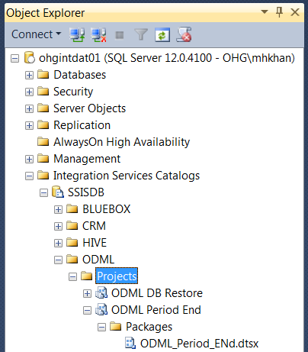

1. **crm_repairs.dtsx**

### Solution and Project:

### 

### Connections:



### Parameters:

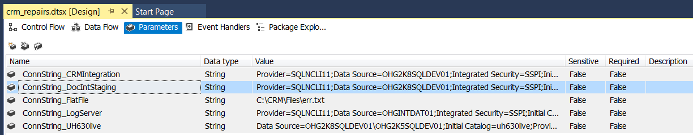

**Control Flow:**

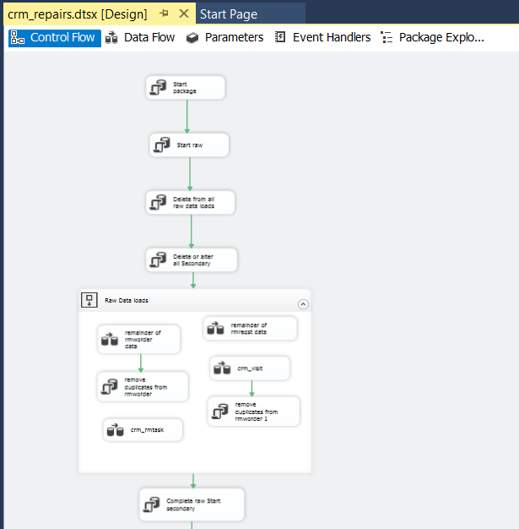

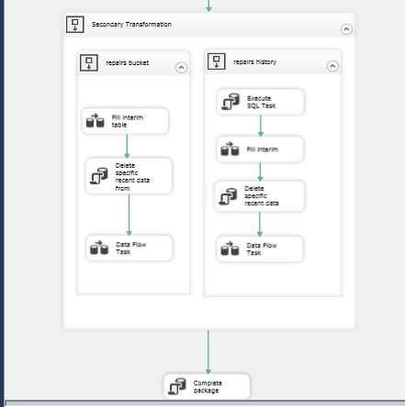

**Deployment:**

Project has been deployed to OHDINTDAT01 (DEV Server) and OHGSTADAT01 (Staging Server)

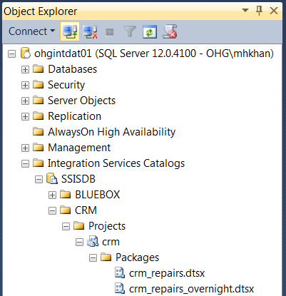

**SQL Server Agent Job:**

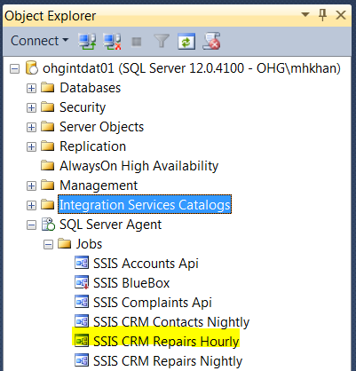

1. **crm_repairs_overnight.dtsx**

### Solution and Project:

### 

### Connections:



### Parameters:

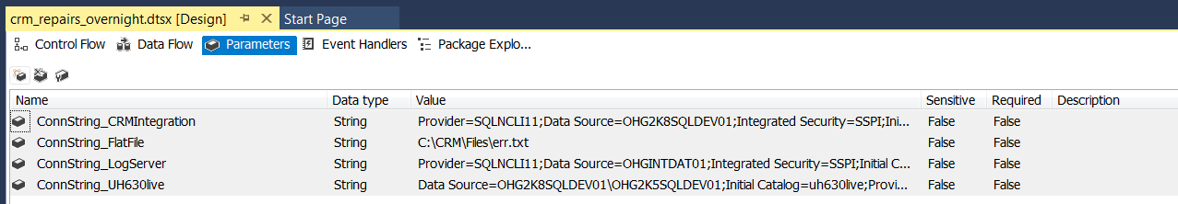

**Control Flow:**

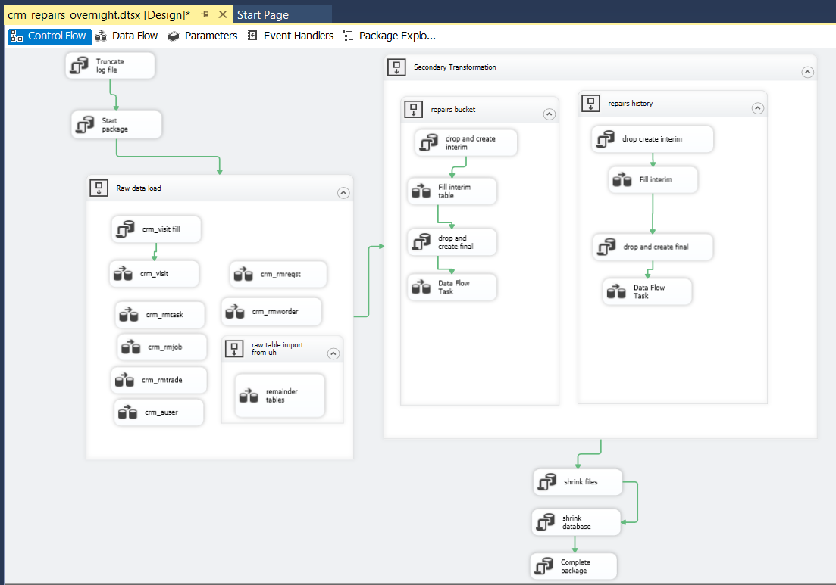

**Deployment:**

Project has been deployed to OHDINTDAT01 (DEV Server) and OHGSTADAT01 (Staging Server)



**SQL Server Agent Job:**

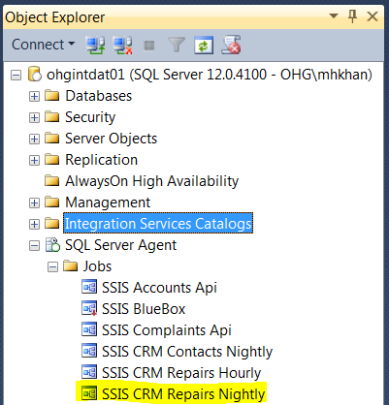

1. **crm_contacts.dtsx**

### Solution and Project:

### 

### Connections:



### Parameters:

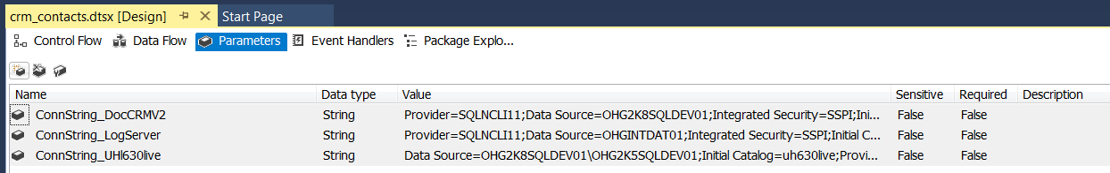

**Control Flow:**

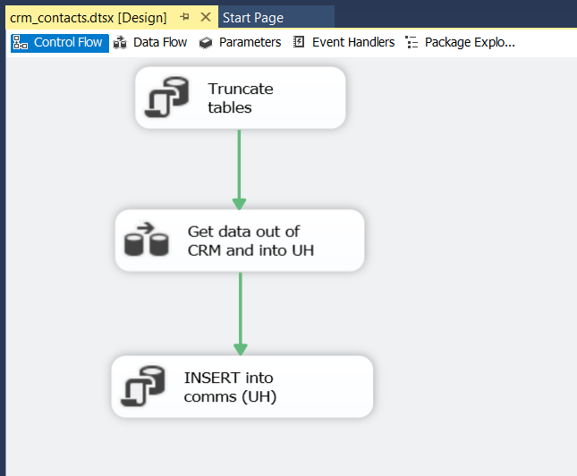

**Deployment:**

Project has been deployed to OHDINTDAT01 (DEV Server) and OHGSTADAT01 (Staging Server)

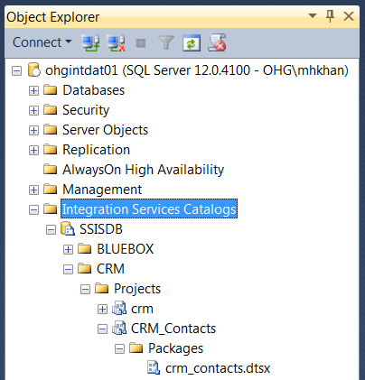

**SQL Server Agent Job:**

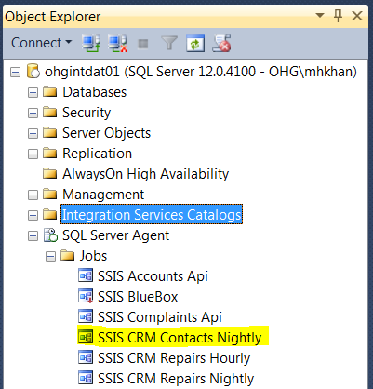

1. **BlueBoxOne.dtsx**

### Solution and Project:

### 

### Connections:



### Parameters:

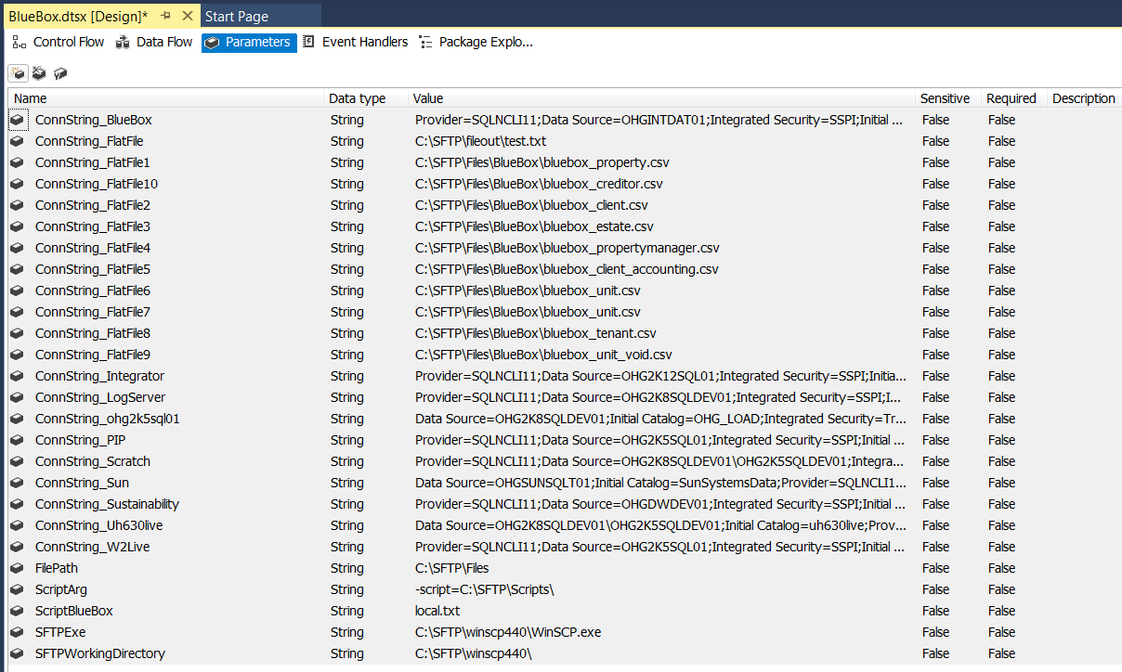

**Control Flow:**

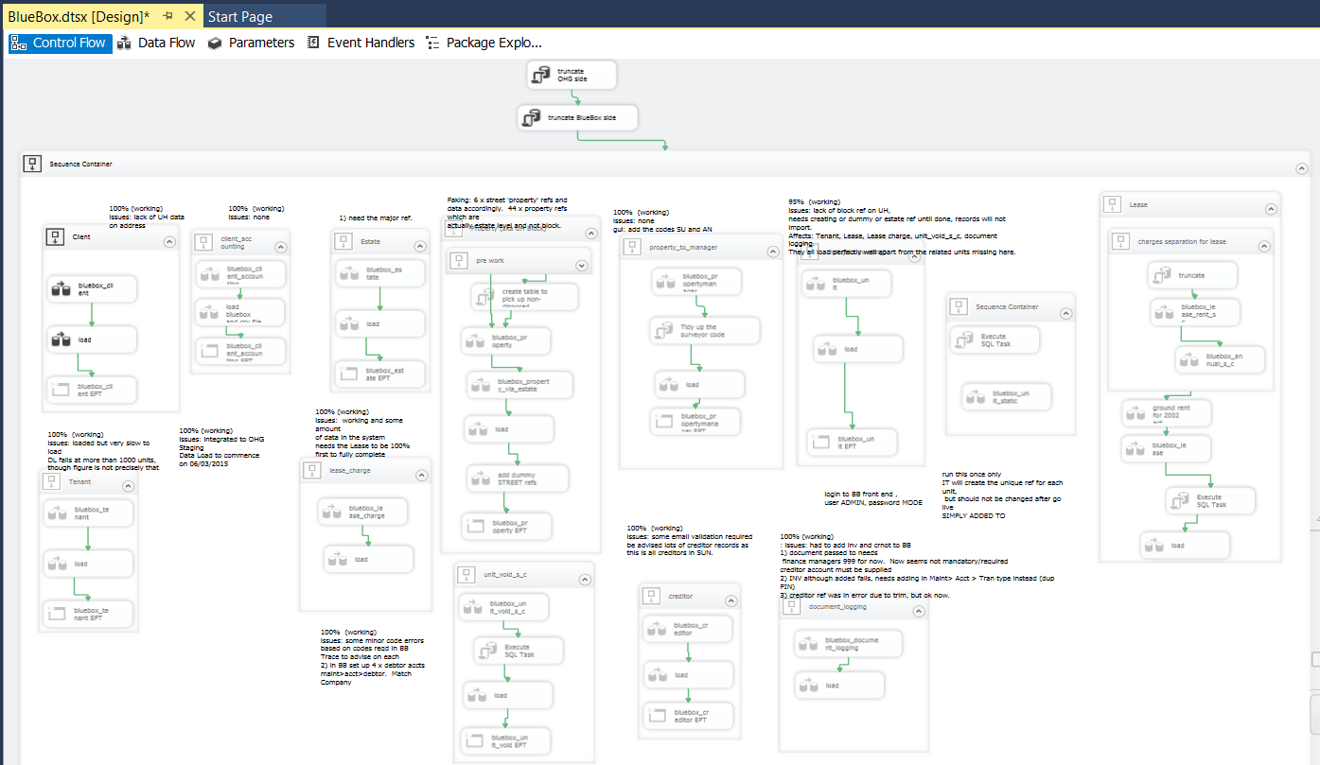

**Deployment:**

Project has been deployed to OHDINTDAT01 (DEV Server) and OHGSTADAT01 (Staging Server)

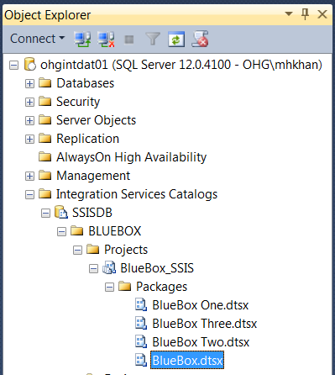

**SQL Server Agent Job:**

BlueBox SSIS package was only used one for data migration at the time of BlueBox Application implimentation. There is no agent jom for this package.

1. **BlueBoxOne.dtsx**

### Solution and Project:

### 

### Connections:



### Parameters:

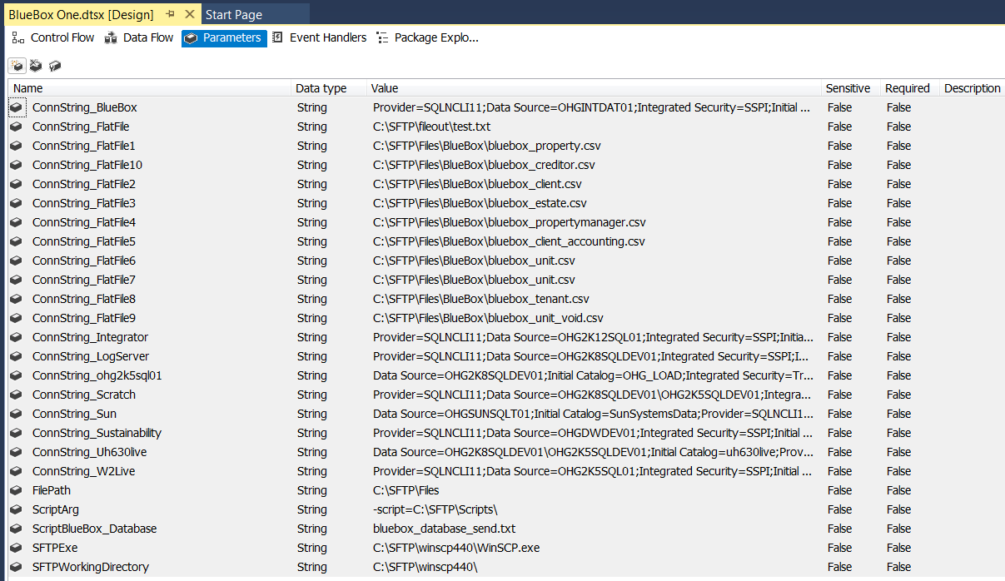

**Control Flow:**

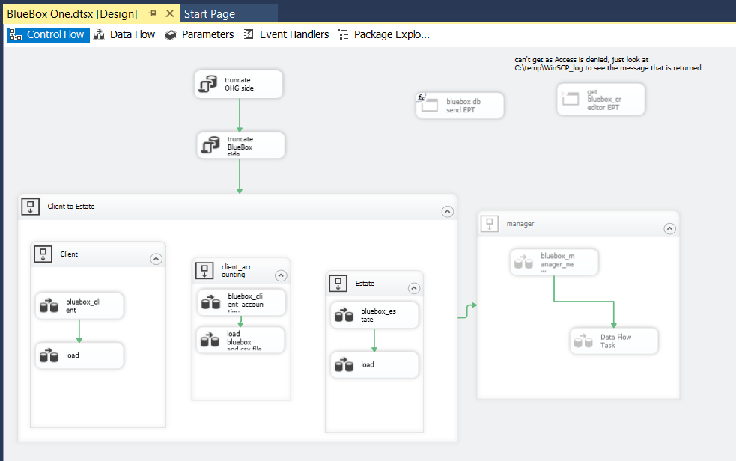

**Deployment:**



**SQL Server Agent Job:**

BlueBox SSIS package was only used one for data migration at the time of BlueBox Application implimentation. There is no agent jom for this package.

1. **BlueBoxTwo.dtsx**

### Solution and Project:

### 

### Connections:



### Parameters:

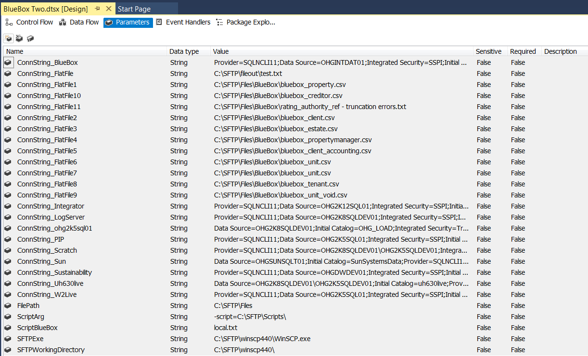

**Control Flow:**

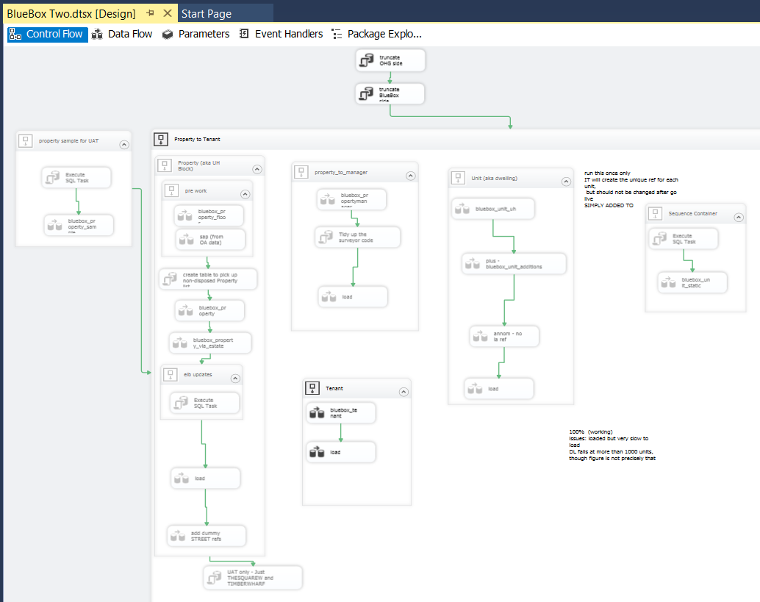

**Deployment:**



**SQL Server Agent Job:**

BlueBox SSIS package was only used one for data migration at the time of BlueBox Application implimentation. There is no agent jom for this package.

1. **BlueBoxThree.dtsx**

### Solution and Project:

### 

### Connections:



### Parameters:



**Control Flow:**

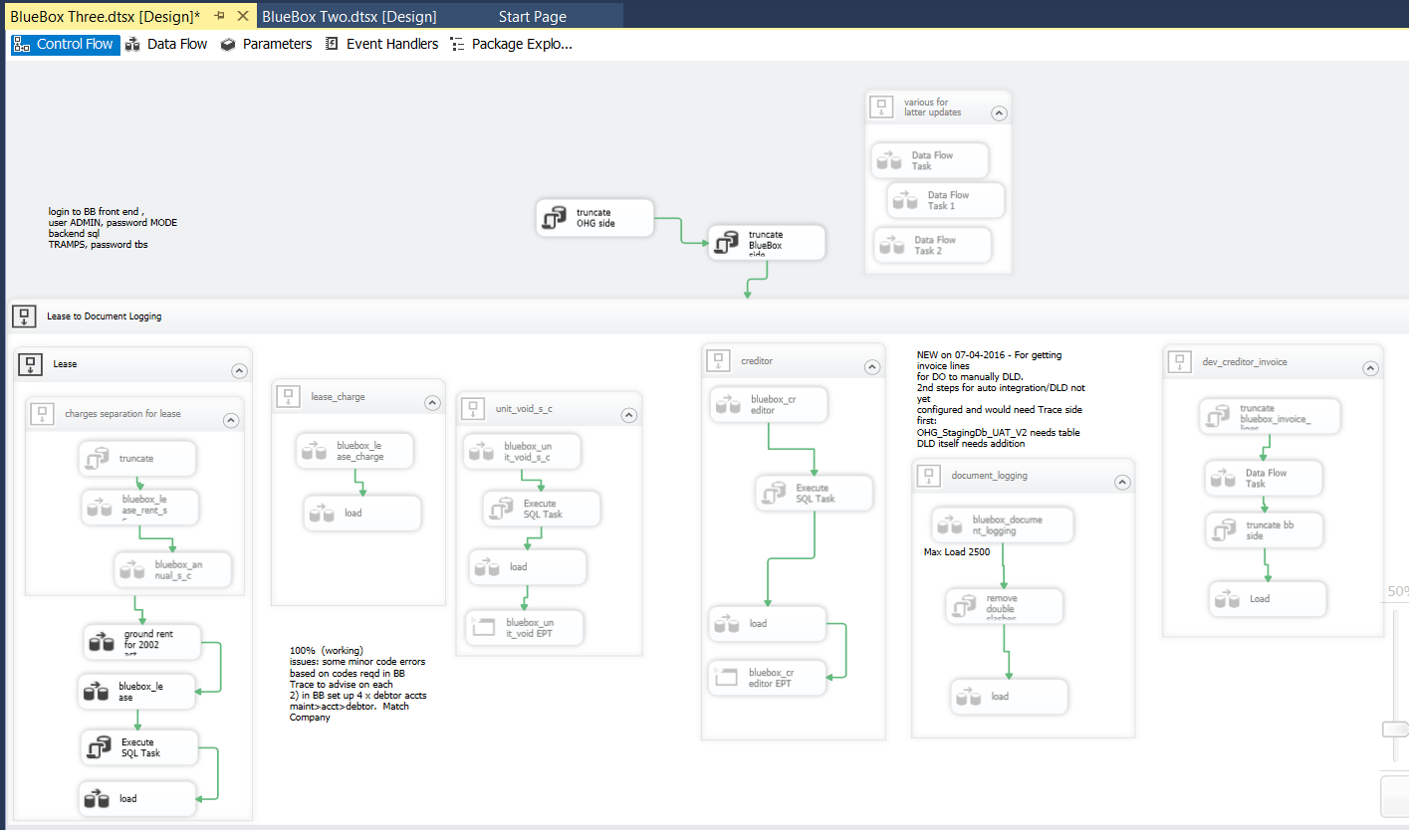

**Deployment:**



**SQL Server Agent Job:**

BlueBox SSIS package was only used one for data migration at the time of BlueBox Application implimentation. There is no agent jom for this package.

1. **HIVE Estate Inspections.dtsx**

### Solution and Project:

### 

### Connections:



### Parameters:

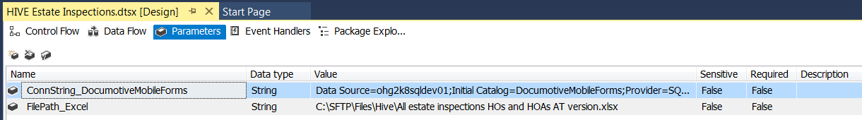

**Control Flow:**

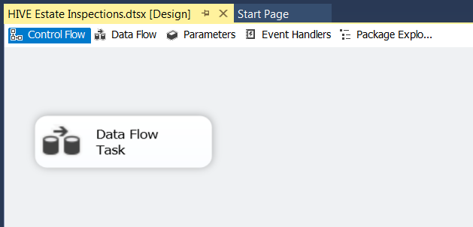

**Deployment:**

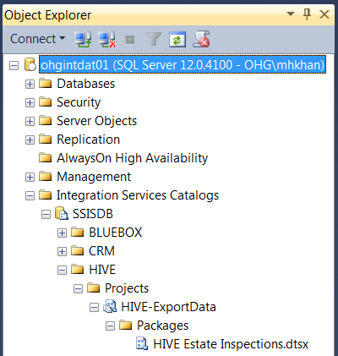

**SQL Server Agent Job:**

HIVE SSIS package was only used one for data migration at the time of BlueBox Application implimentation. There is no agent jom for this package.